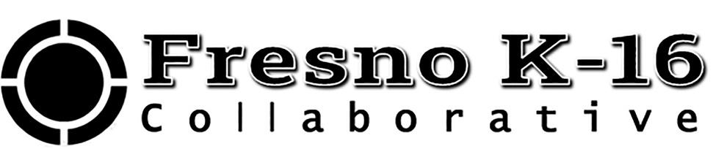
Fresno K-16 Collaborative Executive Steering Committee Meeting Minutes
February 5, 2021

Link to Meeting Materials https://tinyurl.com/FK16C-SCFeb421
Opening: Meeting called to order by Chair President Carole Goldsmith at 3:02 p.m.

Present: Chair C. Goldsmith (FCC), Vice Chair S. Jimenez-Sandoval (Fresno State), J. Yovino (FCSS), A. Jones (SUSD), B. Nelson (FUSD), B. Duran (CVHEC), President Jones (FPU), President Buckley (Reedley), J. Gladney (NU), K. Boone (Clovis USD), N. Salzman (Brandman), P. Birrell (Central USD), P. Parnell (SCCCD)

President Reyna (Madera), D. van Dam (Reedley), B. Berrios (FCSS), C. Brownell (FPU), H. Gutierrez (FCSS), J. Heathcote (Reedley), J. Allen (NU), J. Bedolla (Reedley), J. Olson-Buchanan (Fresno State), K. Cianaci (FPU), K. Kesterke (SUSD), K. Catania (FCSS), K. Boroski (FUSD), L. Hoff (FPU), M. Osorio (CVCF), M. Stricker (GP-CCC Foundation), M. Masoud (NU), R. Nunna (Fresno State), R. Yerrick (Fresno State), R. Ramirez (Fresno City), R. Tuttrup (Fresno City), S. Torres (Reedley), S. Watkins (SCCCD), S. Gutierrez- Mendoza (Brandman), T. Woods (Fresno City), T. Overstreet (FUSD), V. Vuicich (FCSS), T. Lopez (SUSD), V. Madrid-Salazar (CVHEC), J. Ward (FCSS), R. Pimentel (FCC), J. Nino, K. Cianci (FPU), K. Hammerstrom (Fresno K-16), A. Banks (Fresno K-16), S. Lambert (Fresno K-16)

M/S/Approved: Approve December 4, 2020 meeting minutes. Motion by Jim Yovino (FCSS); second by Joseph Jones (FPU)

New Business:
Executive Director Updates:
- Gov. Newsom’s Council for Postsecondary Education website http://capostsecondaryforall.org is live. The Fresno K-16 Collaborative & The Recovery with Equity Taskforce are the two featured initiatives; also features our Executive Committee and their institutions.
- As part of our Marketing through Fresno Pacific, we will be issuing a RFP to integrate or create a website that is more outward facing for students and parents.
- Karri and Dr. Goldsmith will be updating the Governor’s Council on February 11th.
- Virtual Dual Enrollment HUB brainstorming meeting on February 24th at 11am.
- Fresno K-16 Collab will be meeting with DRIVE-Sankofa Race Equity review sometime in March; we will have a premeeting with REI project leads.

Program Proposal Updates:
- Investment Breakdown
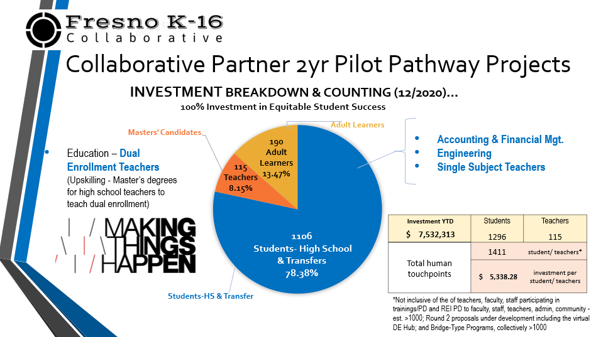
- Additional Round 2 projects being requested. Additional Round 2 project proposals being requested for consideration for FY 20-21: Virtual Dual Enrollment HUB investment (i.e. HS guidance counselor professional development; HS Canvas subscriptions; website landing page and IT upgrades; DE specialists, outreach and marketing); Available funding $1.97M. Brief discussion on how to better engage parents/parent CBOs and equity focused opportunities.

- Program Progress & Successes. Examples – Including: Accounting Winter Bootcamp success, 70 registered. Plans for a Summer bootcamp are underway. Mapping sequences are being drafted. High school students enrolled in dual enrollment. Partner work exceeds budget spending.
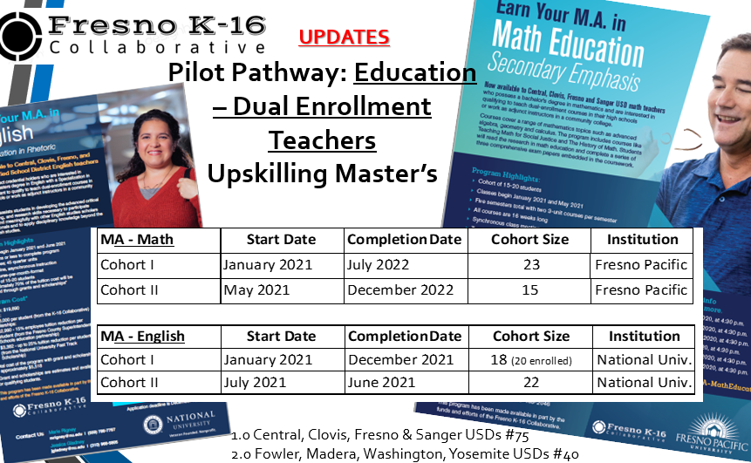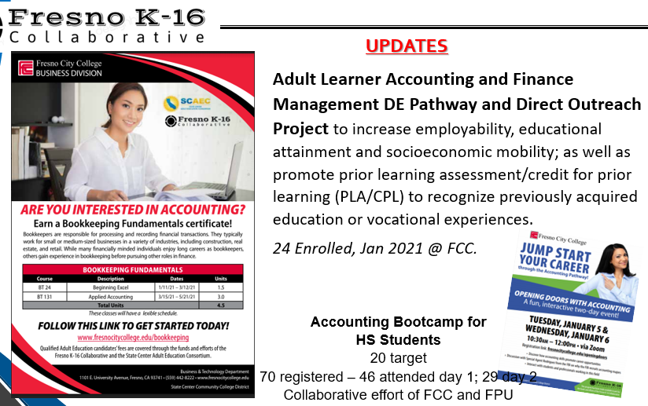

- Contracts in various stages. After OPR approval, most of the contracts have been sent from Foundation back to the partners for their final signatures. Amendments are being processed too. Foundation has been responsive to changes in boiler plate language. Contracts are a formality. The Collab can provide a Letter of Award to partners who need to provide that to their institutions. Asking OPR for flexibility in the Year 1 and Year 2 Prime Award limits to be able to flex between the two FYs; still waiting for a response.

- Progress Report 1 1 is due March 19, 2021. This progress report will summarize plan implementation, activities, and student cohort data to date.
Key deadlines:
March 19, 2021: Progress Report 1 (deadline extended from Feb 5th) summarizing plan implementation to date, activities and student cohort data to date.
September 3, 2021: Progress Report 2 summarizing student outcomes to date (Spring 2021, Summer 2021, Fall 2021 cohort enrollments).
December 31, 2021: Period of performance for each grant award concludes.
January 28, 2022: Final invoicing for expenditure through December 31, 2021 due.
January 28, 2022: Final Report summarizing student outcomes through the end of the performance period and projected to the end of the Academic Year 2021-22

- Roundtable Pilot Pathway Updates and Partner Program Updates:
  - Accounting and Fiscal Management/ Dual Enrollment Spring 2021 Progress, Objectives & Outcomes
  - Engineering/ Dual Enrollment Spring 2021 Progress, Objectives and Outcomes. Engineering Pathway (Dean Nunna) is working on a Dual Admissions MOU between Fresno State and SCCCD colleges that guarantees entrance to that successfully complete the pathway core courses requirement.
  - Updates from Education – Single Subject Teachers and Upskilling Masters, 4/9/21
  - Brandman University will now be known as UMass Global.
  - Update on the Race Equity, Environmental Justice Task Force and subcommittee work (CVHEC, FCC)

Meeting adjourned at 4:18 p.m. Next meeting will be held on April 9, 2021 from 3:00-4:30 p.m. on Zoom

