Fresno K-16 Collaborative Executive Steering Committee Meeting Minutes
December 4, 2020
3:00 – 4:30 p.m.

Link to Proposed Proposals: https://tinyurl.com/FK16C-proposed
Link to Meeting Materials: https://tinyurl.com/FK16C-SCDec4

Opening: Meeting called to order by Chair President Carole Goldsmith at 3:08pm.

Present: Chair C. Goldsmith (FCC), Vice Chair S. Jimenez-Sandoval (Fresno State), J. Yovino (FCSS), C. Nies (UC Merced), B. Duran (CVHEC), A. Jones (SUSD), B. Nelson (FUSD), P. Parnell (SCCCD), J. Endicott (FPU), N. Salzman (Brandman), D. van Dam (Reedley), D. Parra (Clovis USD), J. Gladney (NU)

A. Jacobo-Rousch (FCSS), H. Gutierrez (FCSS), A. Ramirez (CVHEC), V. Madrid-Salazar (CVHEC), L. Hoff (FPU), K. Fleener (FPU), K. Boone (Clovis USD), D. Jansen (FUSD), M. Cantwell-Copher (C2C/FCSS), M. Orosio (DRIVE/CVCF), J. Spevak (CVHEC), R. Yerrick (Fresno State) K. Cantania (FCSS), K. Hammerstrom (Fresno K-16), A. Banks (Fresno K-16), S. Lambert (Fresno K-16)

M/S/Approved: Approve October 2, 2020 meeting minutes. Motion by Vice Chair Jimenez-Sandoval (Fresno State) and second by A. Jones (SUSD). Dale van Dam abstained.
New Business:
Recognition of outgoing Vice Chair Joseph Castro. President Castro is being gifted a personalized cutting board on behalf of the Collab.
Welcome to incoming Vice Chair Saul Jimenez-Sandoval.
Karri provided information on the “First 150 Days” report that was provided to the Governor’s Council on Post-Secondary Education.
Snapshot of Partners, Pathways, & Student Impact to Date:
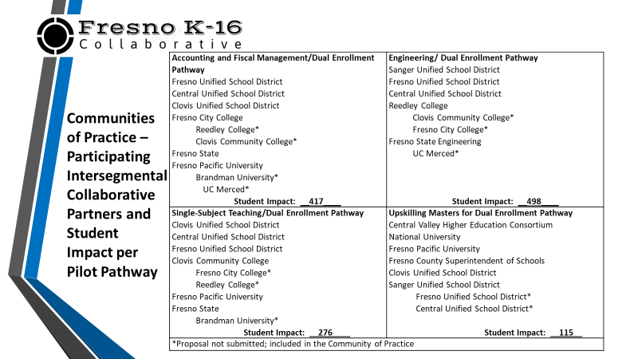

Investment Breakdown:
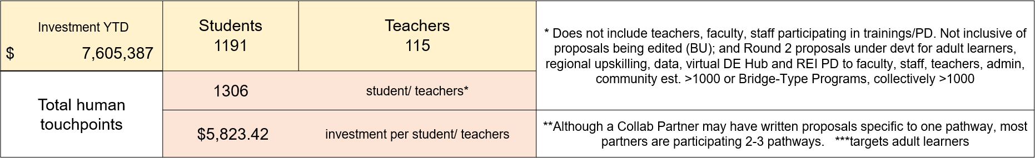
M/S/Approved: Approve proposals for Clovis USD, Adult Learners, and C2C. Motion by B. Nelson (FUSD) and second by Vice Chair Jimenez-Sandoval (Fresno State).
Collaborative Partner | Ask | Students | Teachers | Pathways/Elements
Clovis Unified School District (Boone) | $ 467,317 | 125 | 5 | SS Teacher, Acct, MA
Adult Learners (SCCCD/SCAEC/FCC+FPU/NU/BU) (Watkins/Hammerstrom) | $ 64,173 | 65 |  | Acct ***
C2C Unique ID Creation & Data Sharing (FCSS) (Jacobo/Jansen) | $ 180,000 | na | na | Key Element: IT/Data
Total | $711,490

M/S/Approved: Approve to frontload January MA Upskilling cohorts to match demand and increase May/July cohorts pending demand and available funds. Motion by Paul Parnell (SCCCD) and second by Charles Nies (UC Merced).
Virginia Madrid-Salazar (CVHEC) briefed the committee on CVHEC’s Upskilling plan (dubbed Upskilling 2.0).
M/S/Approved: Approve proposals for Race Equity and Inclusion (FCC+CVHEC) and MA Upskilling (CVHEC). Motion by Vice Chair Jimenez-Sandoval and second by Charles Nies (UC Merced).
Collaborative Partner | Ask | Students | Teachers | Pathways/Elements
Overarching, Regional Race Equity Inclusion (FCC+CVHEC) (Goldsmith) | $205,500 | na | na | Key Element: Race Equity
MA Upskilling Regionally for Sustainability (CVHEC)  (Duran) | $575,000 | na | 40 | MA
Total | $780,500

M/S/Approved: a) Approve to proceed with the development of a Proposal for a Virtual Dual Enrollment HUB; b) Approve to accept proposals from Collaborative Partners who did not participate or did not max out in Round 1. Motion by Jim Yovino (FCSS) and second by Linda Hoff (FPU).
Amber Jacobo-Rousch (FCSS) and David Jansen (FUSD) presented on the C2C Unique ID Creation & Data Sharing project.
Karri provides working group updates. Working groups are meeting on a regular basis. Winter Bridge 2-day program is taking place for Accounting.
Next K-16 Collaborative Steering Committee Meeting: Friday, February 5, 2021, 3:00-4:30pm
Meeting end at 4:25pm.

